Installments

- Choose the sport your athlete is signing up for:
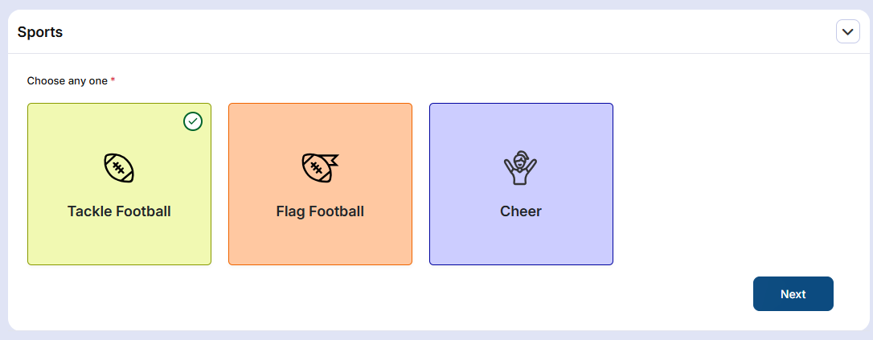
Choose Installments 10 dollar payment for you childs age group. This will just require 10 dollar payment at this time.
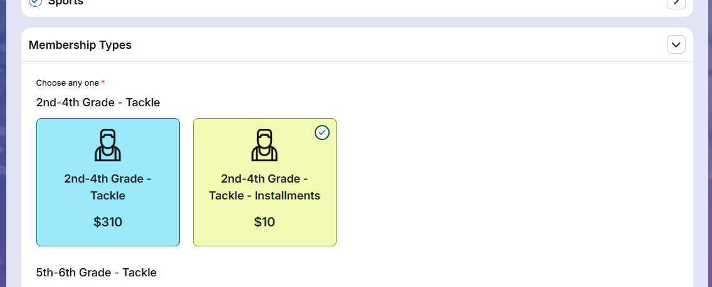

Continue to fill out all the registration information use this document for step by step: Registration WalkThrough

Once you create your atheletes account please watch this video to set up your installments:

